**Technology Skill**

Please note: You must finish all required content to complete these lessons. Please make sure you watch the videos through to the end, complete each activity, read through each tab, and respond to the quiz questions. When you have finished the required content, a blue continue button will appear at the bottom of the screen.

"There has never been a more exciting time to begin or jumpstart a new career. While many people fear what this Digital Age signifies in our day-to-day jobs, I get energized by the prospects, because we get to shape the world around us instead of simply reacting to it."

Jennifer Hill, Head of Artificial Intelligence and Data Science, HP Inc.

Play Video

Play

Loaded: 100.00%

**Remaining Time -1:15**

Captions

Picture-in-PictureFullscreen

Mute

Continued

**This module explores the variety of skills, career paths, and important considerations for those interested in expanding their knowledge of data science and analytics as outlined below:**

| **Technology Skill Module Overview** |
| --- |
| **I. Decoding the Digital Era: A Glossary of Essential Terms** |
| **II. Unlocking Your Data Potential: Essential Skills for Data Science Careers A. Digital Fluency: Cultivating Skills for Today and Tomorrow B. Cracking the Code: Key Skills for Data Scientists and Analysts** |
| **III. Navigating New Horizons: Emerging Careers in the Digital Era** |
| **IV. The Future Rewritten: AI, Machine Learning, and a Shifting Paradigm** |
| **V. Conscious Computing: Harnessing Data and AI for Good** |
| **VI. The Human Touch: Transforming Experiences for a More Connected World** |
| **VII. Safeguarding the Future: Addressing Cybersecurity Risks in AI** |
| **Data Science and Analytics Summary** |

**I. Decoding the Digital Era:  
A Glossary of Essential Terms**

We have spoken about data a lot and data will continue to be our anchor term through our learning path. What is data? Data refers to a collection of information that can be processed and used to inform decision-making and is one of the most valuable assets for making smart and informed decisions.

Data may come in the form of facts, figures, or statistics, or it could simply be text, numbers, images, audio, or video. Data can be generated from many sources too. For example, from physical sensors on roads, to surveys, interviews, social media, web traffic, and more. Data can be systematically collected and organized and made available for analysis.

As we delve deeper into the topic of data science and analytics, it is important to understand the difference between data and information. Data refers to raw, unprocessed facts and figures. Information refers to data that has been processed and organized into a meaningful context.

Continued

**II. Unlocking Your Data Potential:  
Essential Skills for Data Science Careers**

Now that we’ve introduced the data and where we can encounter data, let’s look at some skills that are needed for a career in data science.

**A. Digital Fluency:  
Cultivating Skills for Today and Tomorrow**

When talking about data analysis skills, one of the first things that comes to mind is probably: It’s a lot of math. Yes, there sure is math involved but businesses will require a large range of data-adjacent roles that have different skill profiles. Here are some key skills that will need to come together across contributors to a data project:



Continued

**B. Cracking the Code:  
Key Skills for Data Scientists and Analysts**

**Programming**

Programming languages, such as Python or R, are necessary for data scientists to sort, analyze, and manage large amounts of data (commonly referred to as “big data”). As a data scientist just starting out, you should know the basic concepts of data science and begin familiarizing yourself with some popular programming languages, which include:

* Python
* R
* SQL
* Java

Among this list, Python and R programming are mostly used by data scientists for generating adequate outcomes that are desired by most companies irrespective of their domain.

**Data wrangling and database management**

Data wrangling is the process of cleaning and organizing complex data sets to make them easier to access and analyze. This is also related to understanding database management—you’re expected to be able to extract data from different sources and transform it into a suitable format for query and analysis, and then load it into a data warehouse system.

Useful tools for data wrangling include:

* Altair
* Alteryx
* Trifacta
* Talend

Some of the most important database management tools include:

* MySQL Workbench
* Microsoft SQL Server Management Studio

**Machine learning and deep learning**

Having a complete and thorough understanding of machine learning and artificial intelligence is a must-have in order to implement tools and techniques in different logic, decision trees, etc. Having these skill sets will enable any data scientist to work and solve complex problems that are specifically designed for predictions or for deciding future goals. Some machine learning algorithms to know include:

* Linear regression
* Logistic regression
* Naive Bayes
* Decision tree
* Random forest algorithm
* K-nearest neighbor (KNN)
* K means algorithm

**Cloud computing**

As a data scientist, you'll most likely need to use cloud computing tools that help you analyze and visualize data that are stored in cloud platforms. Some certifications will specifically focus on cloud services such as:

* Amazon Web Service (AWS)
* Microsoft Azure
* Google Cloud

**Data visualization**

Not only do you need to know how to analyze, organize, and categorize data, but you’ll also want to build your skills in data visualization. Being able to create charts and graphs is important to being a data scientist. With strong visualization skills, you can present your work to stakeholders so that the data tells a compelling story of the business insights. Familiarity with the following tools should prepare you well:

* Tableau
* Microsoft Excel and PowerPoint
* Power BI

**III. Navigating New Horizons:  
Emerging Careers in the Digital Era**

The growing need for data insights, predictive analytics, increased agility combined with more complex business decisions has led to an increasing need for proficient data professionals, including data scientists, data analysts, and data engineers. In fact, data science and analytics roles are some of the fastest-growing jobs today, as highlighted by the World Economic Forum (WEF): "The Future of Jobs Report 2023".

If you didn’t notice already, it is worth highlighting that all the fastest-growing jobs incorporate digital components in their daily tasks and the opposite is true for the fastest-declining jobs which rely more heavily on repetitive manual tasks.

**Fastest growing versus fastest declining jobs**

The following slides list the top 10 fastest growing and fastest declining jobs according to the WEF's "The Future of Jobs Report 2023". Please note that the jobs which survey respondents expect to grow most quickly from 2023 to 2027 is a fraction of present employment figures.

* **Top 10 fastest growing jobs**

1. AI and Machine Learning Specialists

2. Sustainability Specialists

3. Business Intelligence Analysts

4. Information Security Analysts

5. Fintech Engineers

6. Data Analysts and Scientists

7. Robotics Engineers

8. Electrotechnology Engineers

9. Agricultural Equipment Operators

10. Digital Transformation Specialists



* **Top 10 fastest declining jobs**

1. Bank Tellers and Related Clerks

2. Postal Service Clerks

3. Cashiers and Ticket Clerks

4. Data Entry Clerks

5. Administrative and Executive Secretaries

6. Material-Recording and Stock-Keeping Clerks

7. Accounting, Bookkeeping, and Payroll Clerks

8. Legislators and Officials

9. Statistical, Finance, and Insurance Clerks.

10. Door-to-Door Sales Workers, News and Street Vendors, and Related Workers.



Navigate through the graphic below to learn about the different jobs within the data science and analytics field, such as a data modeler to an analytics engineer.



Continued

Play Video

Play

Loaded: 100.00%

**Remaining Time -0:37**

Captions

Picture-in-PictureFullscreen

Mute

Continued

**IV. The Future Rewritten:  
AI, Machine Learning, and a Shifting Paradigm**

The advances in computing power, availability of large quantities of data, and algorithm improvements have catalyzed amazing advancements in AI in recent years. Most of these results are powered by deep learning, which can process complex information from unstructured data such as images, audio, and text. Nowadays, thanks to AI systems, we have complex chatbots, facial recognition technology embedded in smartphones, and powerful search engines to locate information.

Individuals with expertise in machine learning can create incredible applications and experiences because of the capabilities of those complex deep neural networks. It enables computers to be able to learn from data, identify patterns, and make predictions without being explicitly programmed. That opens the possibility for applications like:

* Virtual assistants
* Image understanding (e.g. identifying objects, people, and their interactions with the environment)
* Robotics

Continued

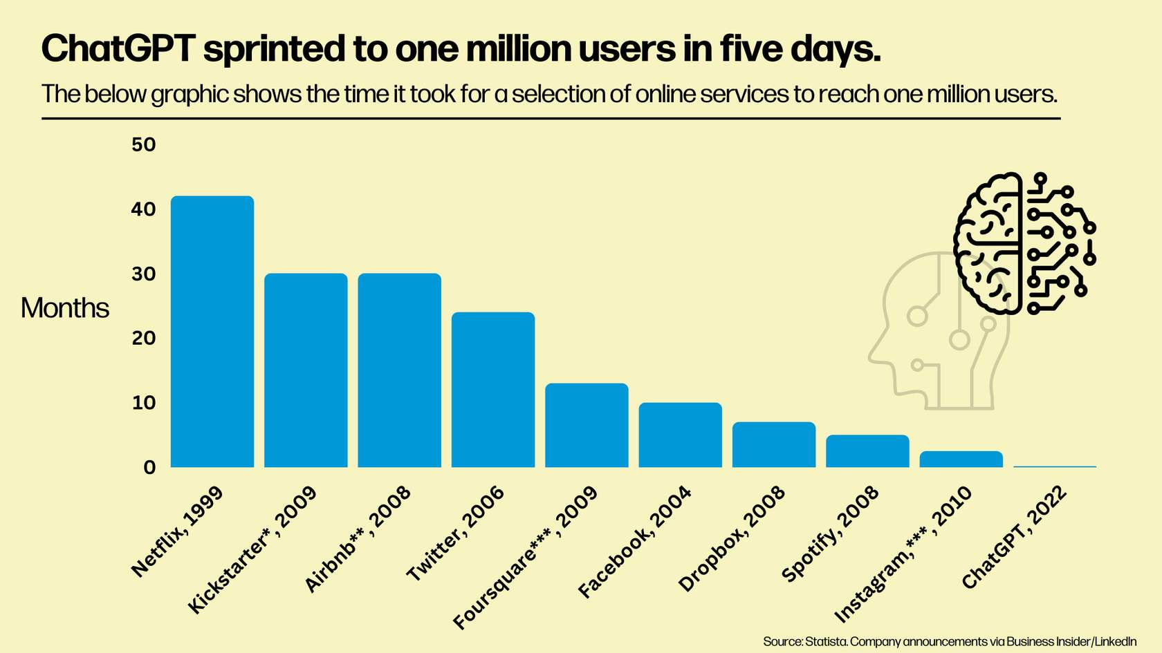

*one million backers; ** one million nights booked;  *** one million downloads

Working with machine learning and AI is an exciting opportunity that can have a significant impact on the world. AI powers important technological innovations such as computer vision, virtual reality, creative design, music composition, and even AI-enabled sports equipment for injury prevention. Embracing these cutting-edge technologies opens doors to transformative possibilities in many fields.

**V. Conscious Computing:  
Harnessing Data and AI for Good**

**The Need for Responsible AI**

As the potential of AI increases and the technology becomes embedded in a wide spectrum of roles in society, we need to make sure the outcome is responsible and aligned for the benefit of everyone. However, having machines move into roles that were previously assigned to humans requires mitigation of possible side effects. The key direction to achieving this goal is to focus on the alignment of the technology with people’s values and ethics. When deploying ML, companies must consider implications at large, including aspects such as fairness, reliability and safety, inclusiveness, privacy and security, accountability, and transparency.

**Fostering Fairness and Inclusiveness**

Concretely, AI solutions must be designed to be inclusive and accessible to people irrespective of social status, racial and ethnic background, or gender. These fairness considerations have fostered a big effort from the industry and scientific community to establish techniques for responsible AI. One of the most popular areas is Algorithmic Fairness, where mathematical principles are used to certify the models will behave according to expectation and fairness guidelines. In summary, one of the reasons Algorithmic Fairness is a central piece of responsible AI is due to the tendency of models to provide hard business decisions using people's data. For example, when deciding on the creditworthiness of an individual in financial applications. Because models rely on data that reflects people’s behavior in society, great care is needed to make sure it is collected properly and does not end up supporting models that exacerbate discriminatory tendencies manifested in local social norms. It is crucial to build fair systems, as hard-to-spot errors and system mistakes are difficult to control.

**Prioritizing Reliability and Safety**

Reliability and other characteristics leading to safety concerns are also part of a broader effort towards responsible AI. In critical applications, like autonomous cars, medical applications, and gaming, the developer needs to make sure the system will not cause physical or emotional harm to users. AI systems have limitations that will demand special attention and specialized practice.

**Safeguarding Privacy and Security**

Privacy and security are also at risk in AI systems. Engineers and executives must align efforts to offer users the possibility to protect their sensitive information, which also includes the right to opt out of the use of their data in ML systems. This has resulted in a large body of regulations for data usage, as can be seen, for example, with the European General Data Protection Regulation (GDPR). An example of these restrictions can be seen in our day-to-day usage of search engines and clicking on new sites. Companies are responsible for asking you whether you want to manage the way cookies are stored for you.

**Pursuing Transparency and Accountability**

The overarching goal of responsible AI is to build AI systems in an accountable and transparent way. You may run across the term, “Explainable AI,” which points to the need to make AI systems more transparent. Being able to argue in favor of responsible AI is deemed an indispensable skill for AI practitioners and continues to be of growing importance to a wide range of stakeholders.

**VII. Safeguarding the Future:  
Addressing Cybersecurity Risks with AI**

With great power comes great responsibility.  This adage most certainly applies to AI.  As we have demonstrated so far, AI can enrich our lives and livelihoods in so many ways.  It is also capable of doing the opposite if practitioners (those developing the AI systems) do not thoroughly address the risks and unintended consequences.  Let’s talk about one of the biggest risk types – cybersecurity.

**Cybersecurity**

The emergence of AI has brought about a new risk in the world of cybersecurity, as malicious actors are increasingly leveraging AI to launch sophisticated attacks on protected systems, financial, political, and otherwise. These bad players exploit AI's capabilities to automate and optimize their attack strategies, making their activities more stealthy, persistent, and difficult to detect. AI-powered attacks seek out vulnerabilities, launch targeted phishing campaigns, and even create convincing deep fake content to manipulate and deceive individuals or organizations. As AI continues to advance, the potential for AI-driven cyber threats becomes more concerning, as bad actors can rapidly adapt and evolve their tactics to outsmart traditional security measures.

However, AI is also proving to be an indispensable tool in bolstering cybersecurity defenses. Cybersecurity professionals are embracing AI-driven solutions to analyze vast amounts of data, identify patterns, and detect anomalies that might indicate potential attacks. AI can quickly sift through massive data sets to recognize suspicious activities and respond in real-time, minimizing response times, and preventing potential breaches. Moreover, AI-enabled threat intelligence platforms can proactively anticipate emerging threats by continuously learning from past incidents and identifying new attack vectors. As the cybersecurity landscape evolves, the role of AI in fortifying defenses against bad players becomes increasingly critical, enabling organizations to stay one step ahead and protect their systems and data from sophisticated AI-driven threats.

You may have heard about data breaches in the news impacting many corporations, both large and small. As we have discussed earlier, data plays an important role in building digital transformation systems, making it critical that data is protected from exposure and theft.  Data breaches occur when vulnerabilities in cybersecurity practices and processes get exploited.

**How can organizations protect themselves?**

An effective cybersecurity strategy is a combination of human factors and, you guessed it, AI-powered detection.  Many AI detection systems use a combination of rule-based heuristics and predictive modeling to detect attempts at intrusion, phishing, and other nefarious activities aimed at an organization.  Defense against these attacks is not just limited to AI and the cybersecurity professionals–every member of a digital organization can take steps to protect themselves by practicing sound cybersecurity habits (such as password rotation, not clicking on links in emails from an unknown sender, and staying informed of new tactics used by attackers).

As digitally capable citizens and members of a digital organization, it is imperative to include cybersecurity strategy as part of your planning and eventual solution.  Fortunately, like everything we have covered so far, there are resources online and a lot of the principles for building data solutions apply here, too. Refer to the Learner Resource Guide for additional resource links to continue your learning journey.

**Data Science and Analytics Summary**

Congratulations! You’ve reached the end of the Data Science and Analytics course. Below are some key takeaways and learnings.

* Making data, technology, and skills accessible to everyone empowers individuals and organizations to thrive.
* Data growth presents challenges such as overload, privacy, security, and infrastructure costs, necessitating stronger data governance and investment in skills development.
* Data analytics and AI bring meaningful solutions, benefiting companies and enhancing human experiences across communities.
* Skills in data analytics encompass technical skills in mathematics and software engineering, as well as foundational skills like creativity and collaboration.
* Data Science and Analytics is a rapidly growing field with more jobs becoming available and continuous learning is crucial for professionals entering the workforce.